🧩 PET High-Clean & Low-Temperature Shredding Solution

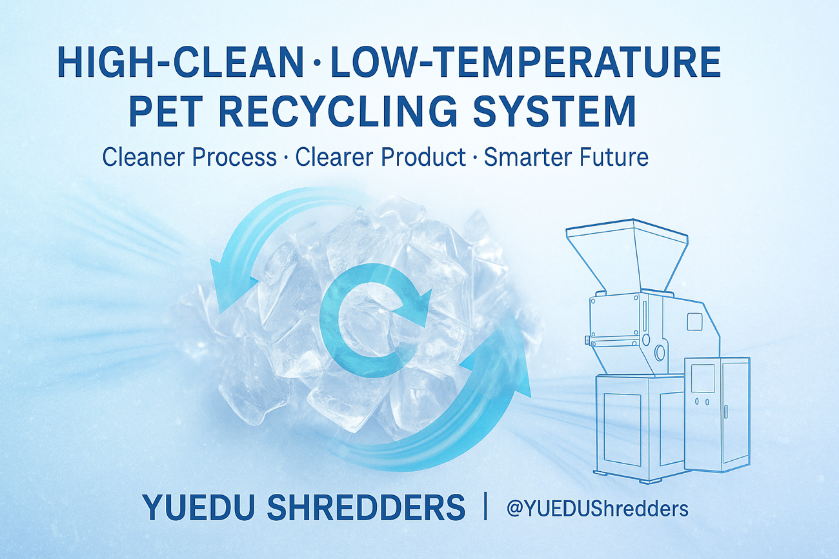

1. Background & Challenges
PET is widely used in bottles, films, and engineering plastics, but during shredding and recycling, conventional machines often cause:
- High temperature → material yellowing and degradation
- Excessive dust → contamination
- Impurity mixing → poor optical clarity
- Low recovery efficiency → higher production cost
High-clean and low-temperature shredding has therefore become the core requirement for premium PET recycling.

2. YUEDU Solution Overview
System Name: YD-SL Series High-Clean & Low-Temperature PET Recycling System
The system is designed specifically for PET recycling processes requiring high clarity and purity.
Through a sealed, low-temperature cutting structure and anti-dust design, the system ensures zero contamination and no thermal degradation during shredding.

3. Technical Highlights
Key Feature | Description
❄️ Low-Temperature Shredding | Keeps temperature rise below 25°C, preventing chain breakage or yellowing.
🧲 High Cleanliness System | Equipped with magnetic separator, anti-static dust collector, and sealed cover.
💨 Low Dust Emission | Fully enclosed air channel; reduces dust output by over 90%.
⚙️ Precision Blade Assembly | Alloy blades ensure consistent particle size and long service life.
🔇 Silent Operation | Noise level below 68 dB, ideal for cleanroom environments.

4. Application Fields
Industry | Application | Benefits
Beverage Packaging | Bottle Flake Recycling | Improves clarity and intrinsic viscosity (IV) of rPET.
Optical Film | Film Waste Recycling | Prevents thermal deformation and maintains transparency.
Plastic Modification | PET Blending & Compounding | Stable particle size for consistent re-pelletizing.
Food Packaging | Recycling to rPET | Meets food-grade safety and clarity standards.

5. 📈 Key Benefits
✅ Purity ≥ 99.9%
✅ Transparency improved by 10–15%
✅ Dust reduced by 90%
✅ Energy consumption reduced by 15%
✅ Compatible with downstream pelletizing and molding lines

6. 🧠 Proven Industrial Experience
YUEDU has successfully implemented PET recycling systems for:
- Coca-Cola – high-clean shredding and recycling for PET preform waste;
- TL Plastic Packaging Machinery – dust-free PET flake recycling system;
- GM Plastic Packaging Machinery – low-temperature crushing line ensuring transparency and consistent quality.
All projects achieved excellent performance in stability, clarity, and cleanliness, proving YUEDU’s PET recycling system as a reliable industrial-grade solution.

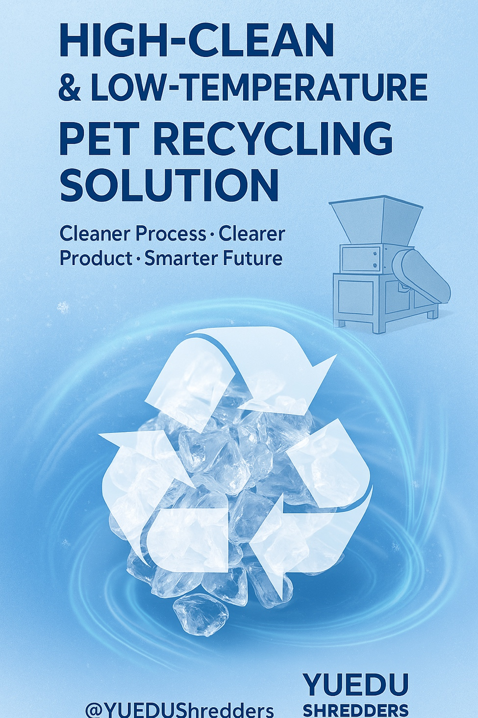

🌐 Contact Us
Shanghai YUEDU Technology Co., Ltd.
📞 Contact Us to explore more customized models and tailored shredding solutions that suit your specific needs!
Let us help you find the perfect equipment for your application.
📱 Sales Supervisor: +86 159 0178 2779 (WhatsApp / WeChat / Facebook)
📱 Administrative Supervisor: +86 137 6138 5116
📧 Email: yuedushredders@gmail.com | denghao8410@gmail.com
🌐 Website: www.yuedushredders.com
@YUEDUShredders – Empowering Global Industries with Intelligent Destruction Systems.

